Sales and Profit Analysis using Microsoft Excel

1. Project Overview
This project analyzes sales and profit performance using Microsoft Excel. The objective is to identify trends in sales, profits, customer behavior, and category performance through Pivot Tables, Pivot Charts, and an interactive dashboard.

2. Dataset Summary
The dataset contains sales transaction details such as Sales, Profit, Category, State, Customer Name, Order Year, and Month. The data was organized and analyzed in Excel to generate meaningful business insights.

3. Data Cleaning and Preparation in Excel
The dataset was cleaned and prepared using Excel tools:
• Removed duplicate values if any.
• Checked and handled blank/missing values.
• Formatted columns correctly (currency, text, dates).
• Organized data into a structured tabular format.
• Used filters and sorting for consistency.

4. Pivot Table Analysis
Pivot Tables were created to summarize and analyze the dataset:
• Sales by Category
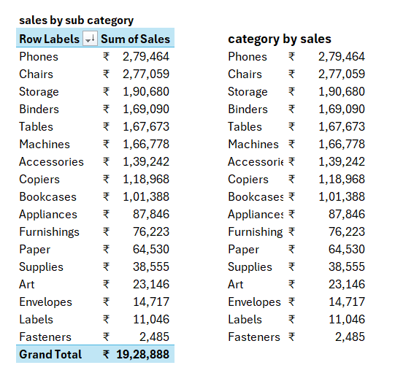
• Profit by Year
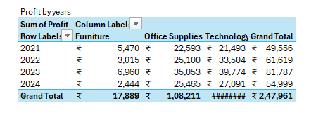

• Customer Count by Year
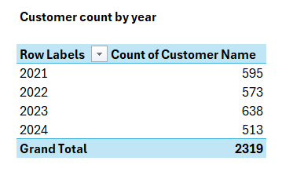
• Sales by State
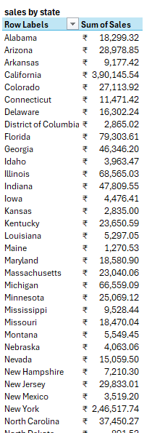
• Top Customers by Profit
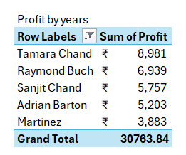
• Sales by Month
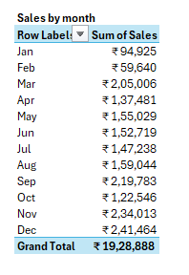
These Pivot Tables helped convert raw data into summarized business insights.

5. Dashboard Creation in Excel
An interactive dashboard was created in Excel using:
• Pivot Charts
• Slicers for filtering data
• KPI cards for Total Sales and Total Profit
• Bar Charts, Line Charts, and Pie Charts
The dashboard provides an easy visual understanding of business performance.

6. Key Insights
• Total Sales: ₹19,28,888
• Total Profit: ₹2,47,961
• Technology and Furniture categories generated strong sales.
• Sales performance changed across different months.
• Some states contributed more revenue than others.
• Top customers generated higher profits for the business.

7. Business Recommendations
• Focus more on high-performing categories.
• Improve marketing strategies in low-sales regions.
• Offer loyalty benefits to top customers.
• Use seasonal sales trends for planning future business strategies.

8. Dashboard Screenshot
Below is the final dashboard created in Microsoft Excel.
